**11.1 What is the On-Site Examination?**

20mm

20mm

The on-site examination makes the core of the examinations for the Deming Prize.

During the on-site examination, the examiners, who have been assigned to an examination unit (refer to 11.4 Notification of the Examiners and On-site Examination Schedule), visit and investigate the status of its TQM practices referring to its DTQMP.

In determining examination units, locations, schedules and the number of examiners for the on-site examination, the Committee considers the applicant’s request and the best possible method for examining the applicant’s TQM implementation status.

　As shown below, the on-site examination consists of applicants’ initiative Schedules A and examiners’ initiative Schedule B. If necessary, a reference examination will be conducted.

　Additionally, during the on-site examination of the examination unit with overall administrative functions, an executive session will be held with top management of applicant organizations.

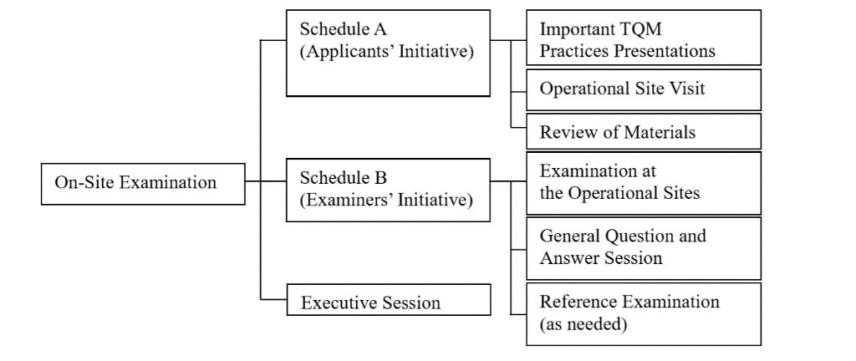　The specific schedules of the on-site examination are determined through discussions between the applicant and the lead examiner at the preparation meeting.

**a) Schedule A**

　Schedule A is the time allocated for the applicant organization to take the initiative in making the examiners understand the status and features of its TQM practices.

　Schedule A consists of Important TQM Practices Presentation, Operational Site Visit and Review of Materials. Specific schedule is decided upon consulting with the lead examiner at the preparation meeting.

90 letters per line.

**1) The Unit's Important TQM Practices Presentations:**

　　These presentations include an explanation of the points that are considered to be particularly important in the Description of TQM Practices and the activities after the submittal of DTQMP which are followed by questions and answers on these points and explanations.

　　As a rule, ratio of the time allocation for the explanation part and Q&A part in the entire Important TQM Practice presentation should be 2 to 1. However, its time allocation will finally be decided taking into account the contents of presentation.

　　It is advisable to provide larger amount of time to Q&A especially for “Outline of the applicant organization”, “Management objective and policy”, and “TQM introduction and promotion” during Important TQM Practice Presentation, e.g. 1 to 1.

Materials supporting the important TQM practices presentation may be presented to or circulated among the examiners on the day of the examination.

**2) The Operational Site Visit**

Designated Format on DTQMP 1 Page Layout

(1) Size: A4

(2) Writing Method: Written horizontally and bound at the left

(3) Margin: 20mm on the left, right, top and bottom.

(4) One page should contain 50 lines with 90 letters per line.

(5) Font of letters: “Times New Roman” at 10.5 point or above

　　For a factory, the operational site visit includes explanations at the operational site regarding production processes such as manufacturing, inspection, testing, packaging and storage; management methods; and products. For a non-factory site, the presentations are made at the sites where jobs are performed. When a

product or its use needs to be understood, explanations may be provided at any appropriate site.

During the operational site visit, explanations should be given so as to enable the examiners to understand the business activities and the method of managing at each process and department. There is no need to make special preparations for this purpose. Rather, the use of existing materials is encouraged.

The time scheduled for the operational site visit should include questions and answers allocating ･･････

20mm

20mm